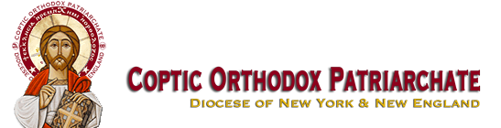

Coptic Orthodox Church of ST. George

1105 67 Street

Brooklyn, NY 11219

(718)259-1564

The 30th Junior Youth Spiritual Retreat

Servant's Registration Form

AUGUST 25-27th 2017 GIRLS

AUGUST 26-29th 2017 BOYS

TWIN PINES CAMP AND RETREAT CENTER

3000 TWIN PINES CAMP RD

STROUDSBURG,PA

Servant’s Name: _____________________________________Gender M /F

Address: ___________________________________________

City: _____________ State: _______ Zip: __________

Phone: (____) ________ Emergency Phone: ( ____) ________

Email:_____________________________________________

Church: ___________________________________________

City: ____________________ State: ______________

Enclosed is my full payment of: $_______________________

Shirt Size: S M L XL

Circle one

