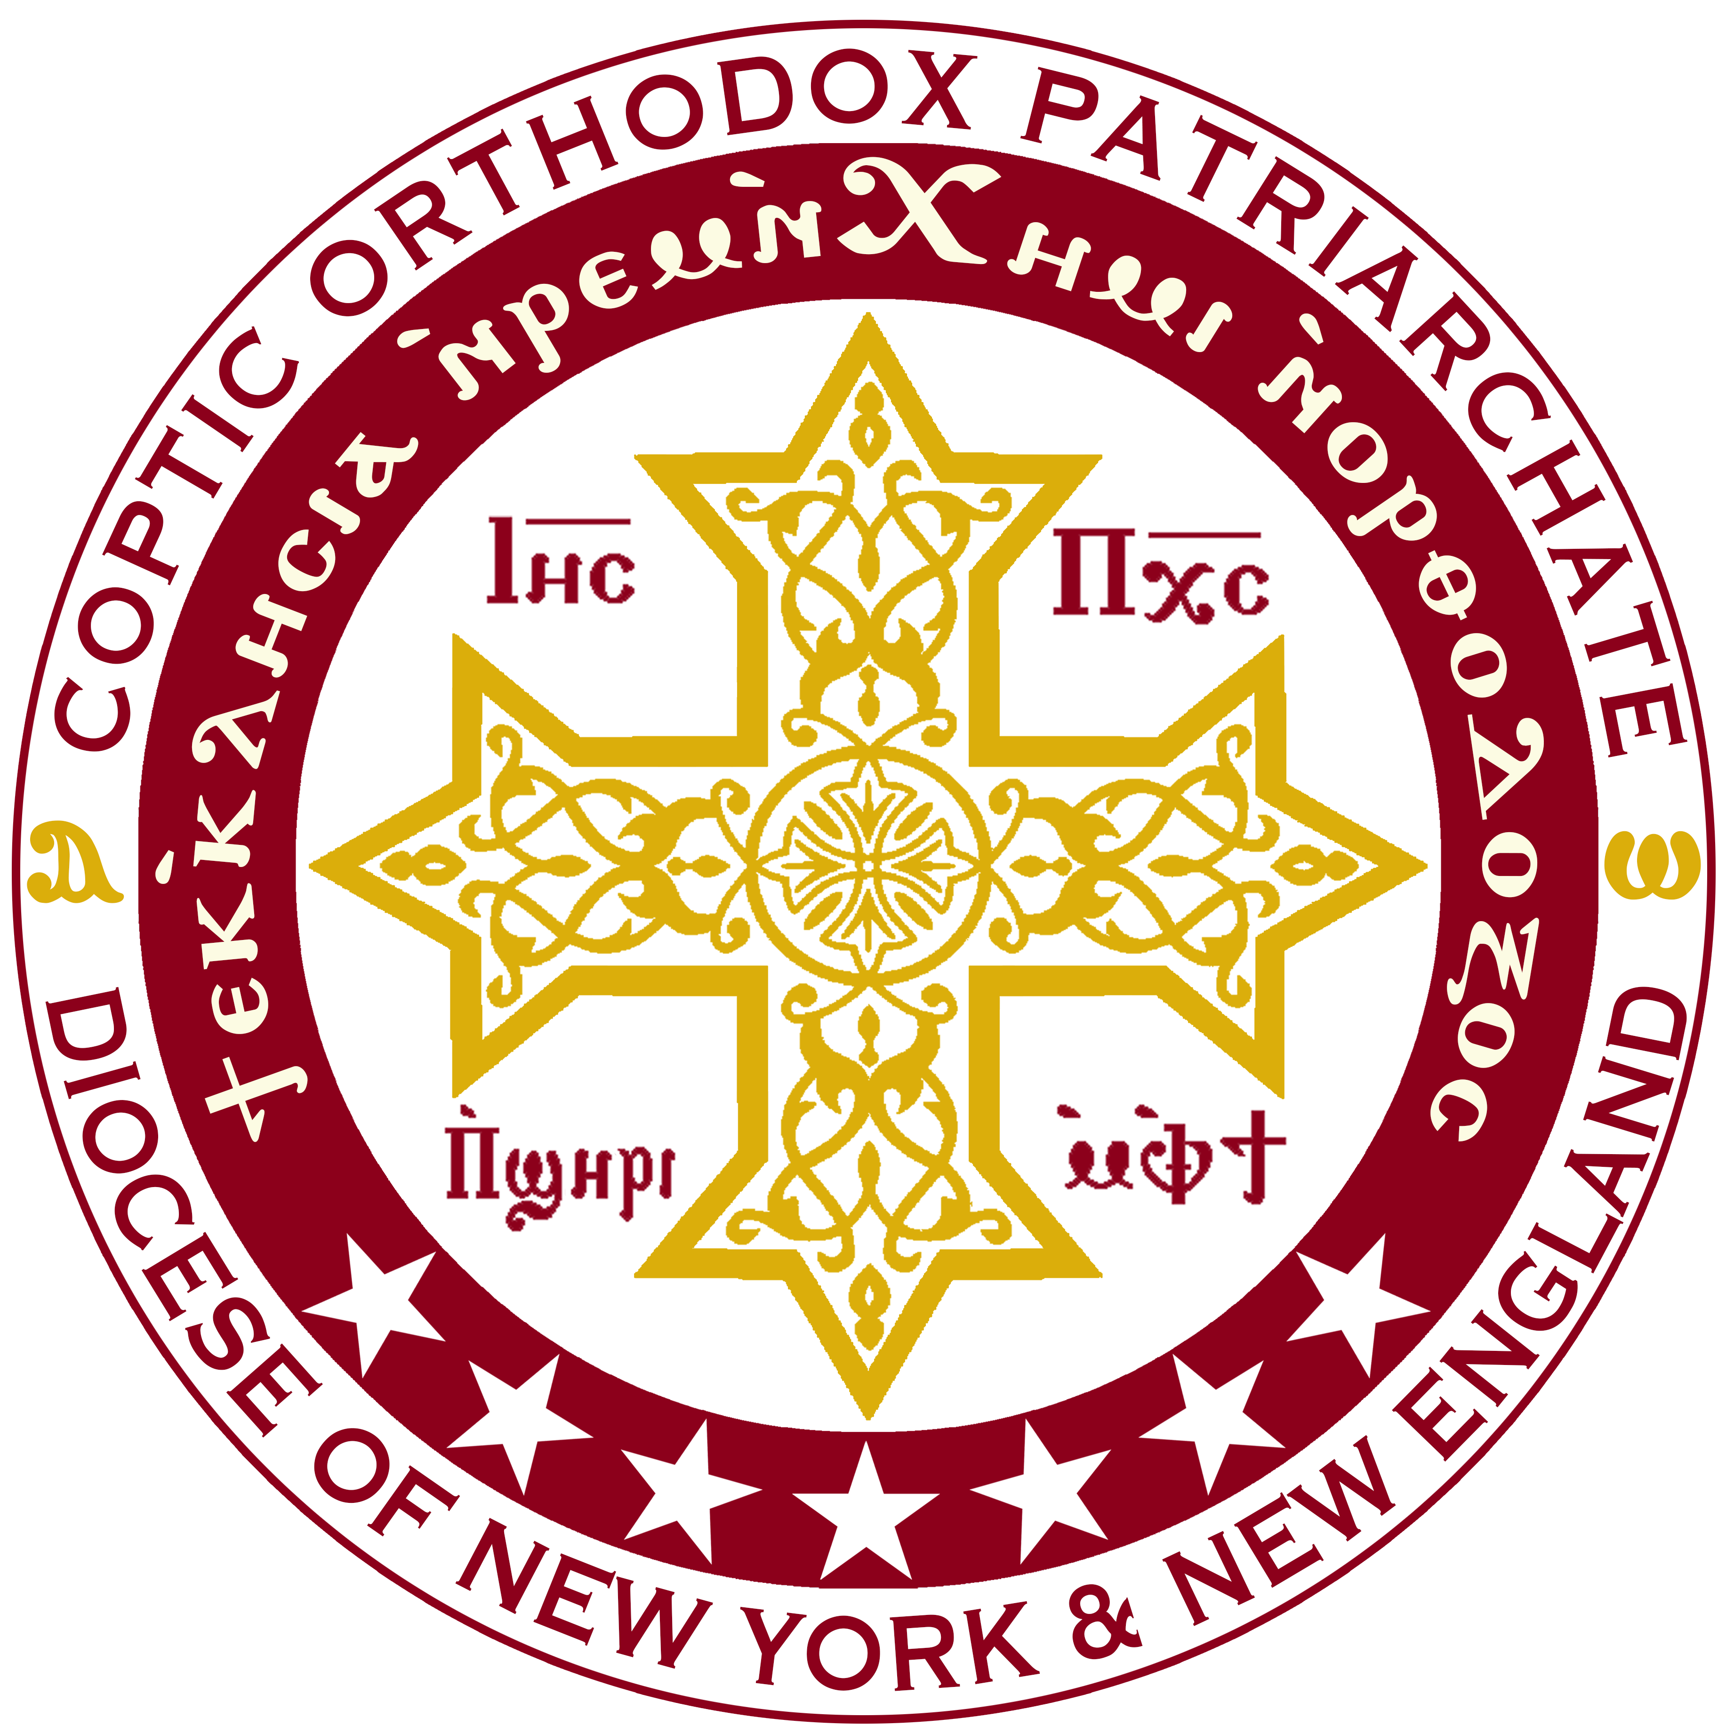
Under the Auspices of H.G. Bishop David
Bishop of the Coptic Orthodox Diocese of New York & New England
NYNE Diocesan Children Committee invites you to
The Fifth Annual
East Coast Children Convention (ECCC)

" Plug Into the POWER "
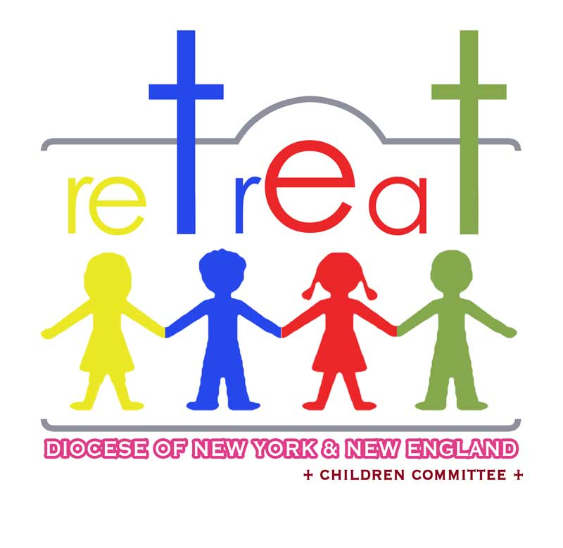
Grades 3, 4 & 5
Friday, Saturday and Sunday
June 12th, 13th and 14th, 2015

Place: Spruce Lake Retreat
Address: 5389 Route 447, Canadensis
PA, 18325

Early registration $100
If paid by: Feb 22nd , 2015
Or $125 after
DEADLINE: June 1ST 2015

The children will learn about the POWER of the HOLY SPIRIT.
Through the use of an acrostic of the word POWER
"P" prayer (II Corinthians 9:8); help "O" others in times of need (II Corinthians 1:3-5); being in God's "W" word (Hebrews 4:12); "E" equipped (Ephesians 2:10); "R" respond (Nehemiah 1:4-11 & II Corinthians 4:18-21).

Workshop of POWER, fun games, crafts, indoors/outdoors sports, music, skits, toasting Marshmallows over a campfire, and great food
For Workshop questions, please call
Fr. Yacob Ghaly (845) 222-5462 or Fr. Luke Awad (917) 576 6051.
For Program questions, please call Fr. Abraham Azmy (203) 887-8865
For activity questions, please call Fr. Youhanna Gobran (508) 612-8837.
For Registration questions, please call Fr. Andrew Awad (203) 455-7447.

Registration/Forms are online www.NYNEcopts.org/ECCC

